**HEATING CYCLE 1**

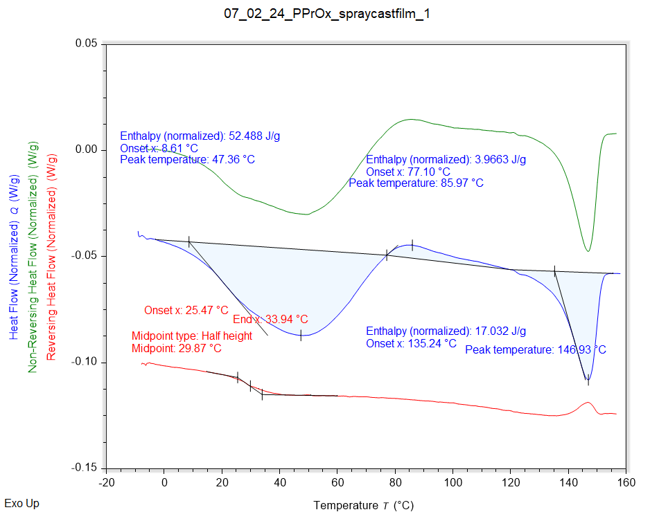

|  |  |  |  |
| --- | --- | --- | --- |
| Solvent HC1 | Peak Onset | Peak Location | Enthalpy |
|  | 8.610 °C | 47.357 °C | 52.488 J/g |

|  |  |  |  |
| --- | --- | --- | --- |
| Recrystallisation HC1 | Peak Onset | Peak Location | Enthalpy |
|  | 77.097 °C | 85.974 °C | 3.9663 J/g |

|  |  |  |  |
| --- | --- | --- | --- |
| Melting HC1 | Peak Onset | Peak Location | Enthalpy |
|  | 135.235 °C | 146.927 °C | 17.032 J/g |

|  |  |  |  |
| --- | --- | --- | --- |
| Tg HC1 | Onset | Midpoint | End |
|  | 25.475 °C | 29.868 °C | 33.944 °C |

**HEATING CYCLE 2**

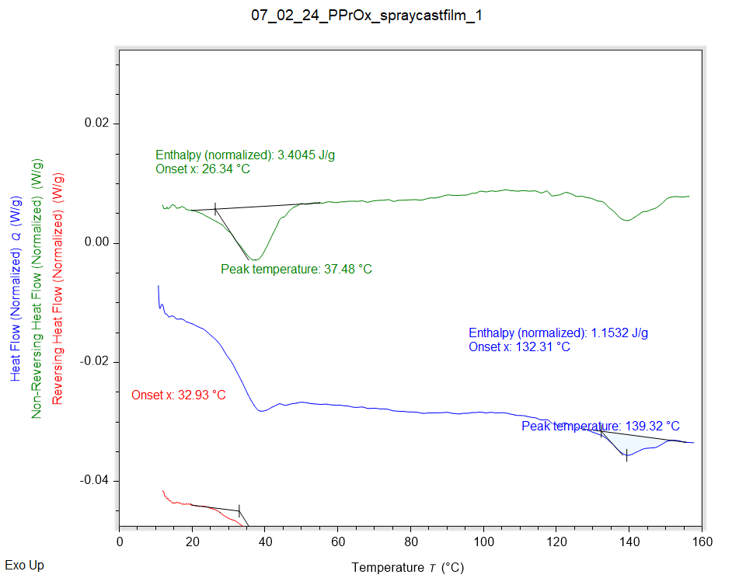

|  |  |  |  |
| --- | --- | --- | --- |
| Solvent HC1 | Peak Onset | Peak Location | Enthalpy |
|  | 26.342 °C | 37.480 °C | 3.4045 J/g |

|  |  |  |  |
| --- | --- | --- | --- |
| Melting HC1 | Peak Onset | Peak Location | Enthalpy |
|  | 132.119 °C | 139.317 °C | 1.1600 J/g |

|  |  |  |  |
| --- | --- | --- | --- |
| Tg HC1 | Onset | Midpoint | End |
|  | 32.932 °C | 39.680 °C | 46.495 °C |

**HEATING CYCLE 3**

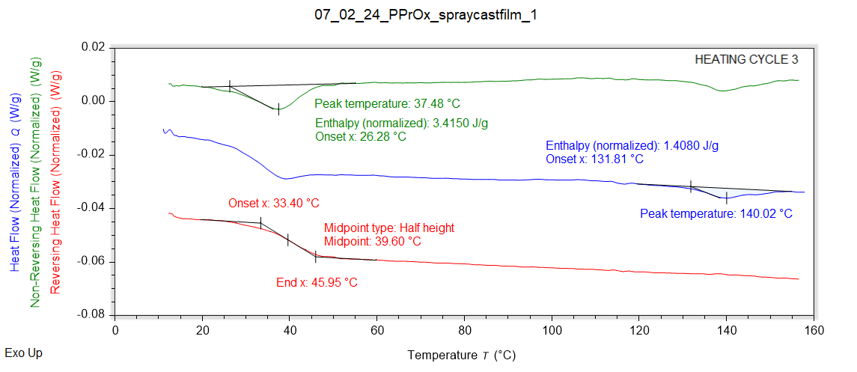

|  |  |  |  |
| --- | --- | --- | --- |
| Solvent HC1 | Peak Onset | Peak Location | Enthalpy |
|  | 26.278 °C | 37.478 °C | 3.4150 J/g |

|  |  |  |  |
| --- | --- | --- | --- |
| Melting HC1 | Peak Onset | Peak Location | Enthalpy |
|  | 131.809 °C | 140.017 °C | 1.4080 J/g |

|  |  |  |  |
| --- | --- | --- | --- |
| Tg HC1 | Onset | Midpoint | End |
|  | 33.397 °C | 39.602 °C | 45.948 °C |